MY21 Global B  
External Amplifier Short to Ground DTCs

DTCs B186C11 and B187F11

# Introduction

This document details the implementation of the following two DTCs for the MY21 Global B VIP:

|  |  |
| --- | --- |
| **DTC** | **Description** |
| B186C11 | Amplifier Control Circuit Short To Ground |
| B187F11 | Entertainment Remote Enable Signal Circuit Short To Ground |

# Circuit Diagram

DTCs B186C11 and B187F11 monitor the voltage state of two GPIO output pins connected to the external amplifier for short to ground conditions. DTC B186C11 monitors the “MUTE” line and DTC B187F11 monitors the “ENBL” line.

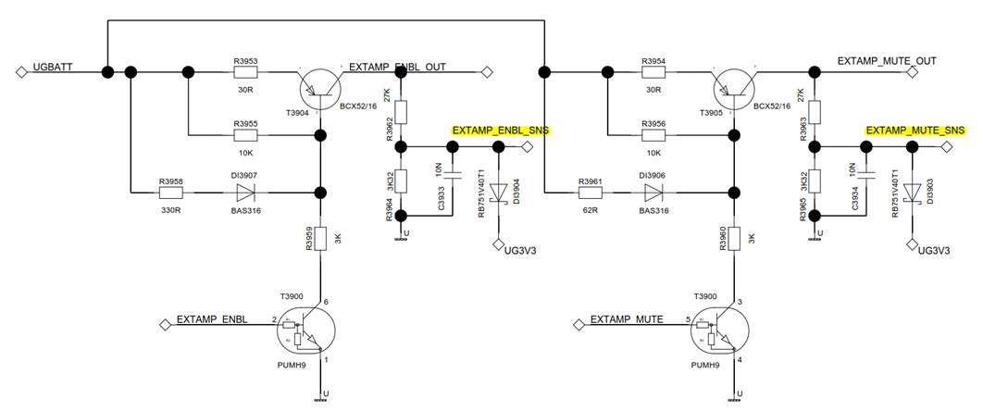

Voltage monitoring on the GPIO output pins is accomplished by means of the ADC pins which are connected to them. See the above circuit diagram.

|  |  |  |
| --- | --- | --- |
| **DTC** | **GPIO Output Pin** | **GPIO ADC Pin** |
| B186C11 | IO_EXTAMP_MUTE (P11_11) | IO_EXTAMP_MUTE_SNS (AP0_4) |
| B187F11 | IO_EXTAMP_ENBL (P11_10) | IO_EXTAMP_ENBL_SNS (AP0_3) |

# Implementation

An I/O Hardware Abstraction component named “IoHwAb_ExtAmp” was created to periodically monitor the ADC voltage on the IO_EXTAMP_MUTE and IO_EXTAMP_ENBL GPIO pins. The voltage is checked on these pins every 100 ms. In addition, all functions for changing the GPIO state of these pins have been moved into this hardware abstraction. All software components which need to mute/unmute or enable/disable the external amplifier should use the functions provided by IoHwAb_ExtAmp (the only exception to this is power.c). Currently, only Appl_Amp_Manager and SWC_AME_Diagnonstics use these functions.

# Algorithm for the Detection of Short to Ground Conditions

The IoHwAb_ExtAmp component reads the raw ADC voltage value on the IO_EXTAMP_MUTE and IO_EXTAMP_ENBL lines every 100 ms. The algorithm for detecting a short to ground condition on the GPIO lines can be represented by the following pseudocode:

IF Expected GPIO State = HIGH AND Actual GPIO State = LOW THEN

Short to Ground Detected = TRUE

ELSE

Short to Ground Detected = FALSE

END IF

Where:

Expected GPIO State = the state of the line being driven by the application software

Actual GPIO State = the actual state of the line as indicated by the ADC voltage reading

So a short to ground condition can only be detected if the application software is driving the GPIO line HIGH. If the GPIO line is being driven LOW, then a short to ground condition is not detectable.

A “LOW” condition on the GPIO line is defined as a raw ADC reading that is lower than 250.

When a short to ground condition is detected, a message is sent to the SWC_DTC_Handling component. If this state is detected continuously for 5 seconds, then the appropriate DTC is set. The DTC will be cleared immediately when the short to ground condition is no longer detected.

# Calibrations

The DTCs can be turned off or on by their respective DTC_MASK calibrations:

|  |  |
| --- | --- |
| **DTC** | **DTC_MASK Calibration** |
| B186C11 | DTC_MASK_B186C_11 |
| B187F11 | DTC_MASK_B187F_11 |

They are also dependent on the AmplifierType calibration:

|  |  |
| --- | --- |
| **AmplifierType** | **DTCs B186C11 and B187F11** |
| Internal Amplifier (0) | Disabled |
| Analog Remote Amplifier (1) | Enabled |
| Remote ANC Amplifier (2) | Enabled |
| Bose Premium Amplifier (3) | Enabled |

# Enable Conditions

DTCs B186C11 and B187F11 have the following enable conditions:

Vehicle Supply Voltage is between 9.0 and 16.0 Volts

Enabled when the supply voltage is in the correct range.

Operation Cycle: DEM_OPCYC_IGNITION

Enabled when Power Mode is either Run or Propulsion.

Vehicle Power Mode = Run or Propulsion for 5 seconds.

Enabled when the Power Mode is Run, Propulsion, or Accessory for at least 5 seconds.

Vehicle Operating Conditions: Any Partial Network that the ECU participates in is active.

Enabled whenever any of the following PNs is active (see GB5280 for details):

Propulsion PN  
Vehicle Access  
Driver Notification  
Interior Lighting

# Viewing Debug Information

You can turn on DEBUG level log statements in the VIP log to view the raw ADC voltage values being received by IoHwAb_ExtAmp. To do so, enter the following commands on the SoC Tera Term console:

IPCTestAppGen –c 13  
2  
8203

# AME Commands

You may also use the following AME commands to change the state of the GPIO pins. This may be especially helpful for testing purposes.

|  |  |  |
| --- | --- | --- |
| **AME Command** | **GPIO Pin** | **Values** |
| 8780 | IO_EXTAMP_ENBL | 00 = Disable, 01 = Enable |
| 8781 | IO_EXTAMP_MUTE | 00 = Unmute, 01 = Mute |